**Waveform/Signal** = a plot of amplitude over time, representing encoded data for transmission

**Amplitude** = measuring the **height** **of a waveform** *(from the middle)*. In electronic signaling, we measure the discreet voltage, but this could also have been the voltage pressure (amps) or wattage (volts multiplied by amps). Other means of measuring signal amplitude could involve the electromagnetic or light spectrum

**Frequency** = number of times a signal makes a complete cycle (oscillation) in a given timeframe

**Hertz** = number of cycles per second

**Period** = length of one cycle measured in time

**Spectrum** = The minimum to maximum range of frequencies found in a signal

**Bandwidth** = The absolute difference (always positive) between lowest and highest frequencies. The *effective bandwidth* (real usable freq. range) is typically less due to potential noise interference

**Phase** = the relative position (angle) of a signal at a given point in time or relative to time zero *(see later)*

**Wavelength** = measuring the distance between signal crests / troughs = Crest to crest OR Trough to trough

**Modulation** = the process of mixing an information signal within a carrier wave, typically a sinusoid (smooth oscillating sinewave), in order to produce a new signal to transmit. After transmission, removing the carrier wave then produces the information signal (de-modulation). Typically, we can either vary the carrier signal frequency, amplitude or phase.

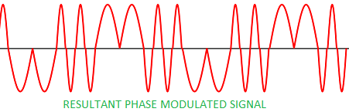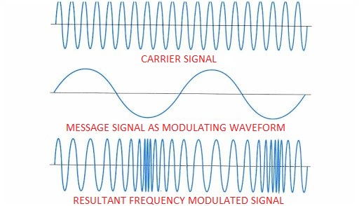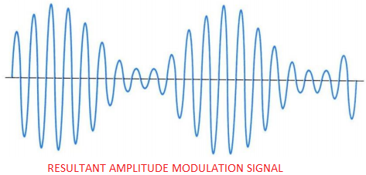**Frequency Modulation (FM) =** varying the frequency of the carrier wave, based on the amplitude of the message signal. Note, as you can see from the diagram below, the FM signal’s amplitude stays the same, only the frequency of the signal changes based on the message signal’s amplitude

**Amplitude Modulation (AM)** = varying the amplitude of the carrier signal, based on the amplitude of the message signal

**Phase Modulation (PM)** = varying the phase angle of the carrier wave, based on the amplitude of the message signal

**Attenuation** = natural loss of signal power (intensity) over distance, due to friction/resistance to signal propagation (as it travels across the medium)

**Decibel (dB)** = relative logarithmic loss or gain (as a ratio) of signal power. The difference in dB for two signals can be measured as 10 log (P2/P1) dB

* Signal P2 is twice as strong as the signal P1, therefore we have a gain of 10 log (2/1) = 3 dB
* A signal arrived at the receiver (P2) with 30 watts of power, but was sent from the transmitter (P1) at 50 watts of power, therefore we have a loss of 10 log (30/50) = -2.2 dB

**Amplification** = the opposite of attenuation and always signifies a decibel gain

**Overall Signal Loss/Gain** = adding all dB losses and gains for a signal along its transmission path

**Noise/Interference** = generated by an external force, noise degrades/reduces a signal’s intensity [could come from diverse sources such as electrical cross-talk, electromagnetic interference (EMI), radio frequency interference (RFI), thermal noise and others]

**Deterministic signals/waveforms** = the waveform is predictable over time

**Discreet signals** = A specific subset (sample) of a waveform measured within in a known timeframe

**Analog signals** = a continuous waveform (infinite number of values) that changes over time analogous (similar) to a sine wave.

* Advantages: Large transmission distances, high data density (more values), easy processing
* Disadvantage: difficult to separate noise, suffers from generation loss (each time the signal passes through devices along the transmission path, the signal loses accuracy)

**Digital signal** = a fixed number of values (typically one or zero) represented as a square waveform

* Advantages: Speed of transmission and throughout is higher than analog, tolerant to noise
* Disadvantages: Short transmission distances, complex processing, large bandwidth needed

*Digital information can be transmitted using analog signals and also the other way around. All transmission combinations possible then produces:*

1. Analog data via analog signals (**Frequency / Amplitude / Phase Modulation**)
2. Digital data via square waveform digital signals (**Encoding Schemes**)
3. Digital data via discrete *[specific value range]* analog signals (**Keying**)
4. Analog data via digital signals (**Pulse Code Modulation / Delta Modulation**)

Transmitting analogy data with analogy signals – **FM, AM, Phase modulation**

Transmitting digital data with square-wave digital signals: Encoding Schemes

*Digital data is converted to a physical form for transmission. 1’s could be transmitted as positive voltage (+5v), whereas 0’s could be transmitted as zero voltage (0v). Or vice versa.*

**Baud Rate** = the number of times a signal changes value per second (does not mean data is discernable)

**Bits per second/data rate (bps)** = number of actual bits transmitted per second

**Non-return to Zero-Level (NRZ-L) Encoding =** 1’s at zero voltage and 0’s at positive voltage, therefore receiver must check voltage level on a per bit basis to differentiate

**Non-return to Zero Inverted (NRZI)** **Encoding** = voltage change at the start of 1’s, no voltage change for 0’s, therefore receiver only needs to check for voltage changes to determine bits

Advantage (both): Baud rate equals bit rate (bps) = cheaper h/w due to lower processing overhead

Disadvantage (both): Long sequences of zeros is a problem, we need clock synchronization between sender and receiver, at the respective end-points too discern bits

**Manchester Encoding** = A potential slot for transmitting either a 0 or 1 in the signal is known as an ***interval***. 1’s is transmitted by moving the signal from low too high in the *middle* of an interval. 0’s is transmitted by moving the signal from high to low in the *middle* of an interval. Therefore, the beginning of the interval also requires adjustment between bits

**Differential Manchester** **Encoding** (historically used in token ring networks) = there is still a transition of the signal in the middle of an interval; however it now does not identify data bits. Instead, if there is a change in signal value at the *beginning* of an interval a 0 is being transmitted. If there is no transition at the *beginning* of an interval, a 1 is being transmitted

Advantage (both): Solves the synchronization problem between sender and receiver (***self-clocking***)

Disadvantage (both): Half the time, there could be two transitions per bit transmission (***baud rate is twice the bit rate = inefficient = 100% overhead***), more expensive h/w for processing, additionally more susceptible to noise

**Bipolar-AMI Encoding** = a binary 0’s is zero voltage, whereas 1’s is either positive or negative voltage (decided from last 1 sent)

Advantage: All transmissions sum to zero volts, said to be useful in electronics systems

Disadvantage: Long sequences of zero present synchronization problems, special hardware that can read both positive and negative voltages

**4B/5B Encoding** = satisfies the synchronization problem and avoids baud rate twice the bps issue. A message nibble (4 bits) is translated into a unique 5-bit sequence [25 = 32 possibilities of which only 16 are used] which is then sent using Non-return to Zero Inverted (NRZI) Encoding. No more than 2 consecutive 0’s are ever produced.

Advantage: Baud rate is equal to bitrate, self-clocking

Disadvantage: still has a 20% overhead (the additional bit)

## Transmitting digital data with discrete analog signals: Keying

## * a predetermined range of values/levels

**Amplitude Shift Keying** = In its simplest form, 1’s or 0’s takes on a constant amplitude within a signal period, thus baud rate equals bit rate at a minimum. In other forms amplitude changes could represent multiple bit pairs. Example: if 4 amplitude levels are provided for we could encode 2 bit pairs uniquely as 00,01,10,11 – generating data rate (bps) twice the baud rate.

Advantage: better efficiency than Manchester encoding

Disadvantage: susceptible to sudden noise spikes (electrical noise that significantly increases amplitude produces data loss), not suitable for high data transmission rates (<1200 bps)

**Frequency Shift Keying** = 1’s and 0’s has different constant frequency ranges per period.

Advantage: not susceptible to noise spikes that cause data loss

Disadvantage: subject to ***intermodulation distortion*** (two or more signals mix to create a new frequencies), not suitable for high data transmission rates

**Phase Shift Keying** = In its simplest form, phase angle changes per period represent 0’s or 1’s. No phase change equals 0, 180o degree phase change equals 1.

**Quadrature Phase Shift Keying** = Sending 2 bits per period requires 4 phase changes or 22. Or in reverse, the number of phase changes determines the number of bits sent or log2.

Per Example: four different phase angles at 45o (11), 135o (10), 225o (01) and 315o (00) degrees represent unique 2-bit pairs. Sending more bits per period requires more phase angle changes to be detected. Sending 3 bits requires 23 = 8 phase angle changes and so forth.

**Quadrature Amplitude Modulation** (high speed modems/digital TV) = Combines phase angle changes with differing signal amplitudes. Typically, 4 bits are represented using only 12 phase angles + 2 amplitude levels = 16 combinations.

Advantage (above): less susceptible to noise, can be used at higher frequencies/data rates

## Transmitting analog data with digital signals: Pulse Code & Delta Modulation

**Pulse Code Modulation (PCM)** (in h/w a ***codec***) = converts analog data to digital signal by sampling/snapshotting the analog data at fixed time intervals and generating a fixed binary value. Snapshotting requires calculating the analog waveform height or voltage above a given threshold/ ***quantization level***. This process is known as ***Pulse Amplitude Modulation [producing a PAM value]***. Signal transmission is then achieved via digital encoding formats.

**Quantization Error/Noise** (Related terms: Sampling error, Generation loss) = generating or regenerating the analog data, produces inaccuracies from the original analog data due to rounding and approximation. To reduce quantization error, you could increase the quantization levels or sampling rate. However, this produces more binary data, for uncertain gain.

*Nyquist theorem for PCM:* sampling rate should be twice the highest frequency of the original analog waveform for reasonable reproduction quality

**Delta Modulation** = assesses incoming analog data during a given time period (sample), to determine whether the waveform has risen up or down a delta step. A rise (delta up) generates a 1, where as a drop (delta down) generates a 0. Therefore, only 1 bit per sample is generated.

Advantage: more efficient than PCM (as PCM requires two steps = PAM + digitization)

Disadvantage: sharp upward or downward waveform trends (slope overload noise) could stress the codec leading to additional generation inaccuracy, non-changing waveforms produce quantization noise